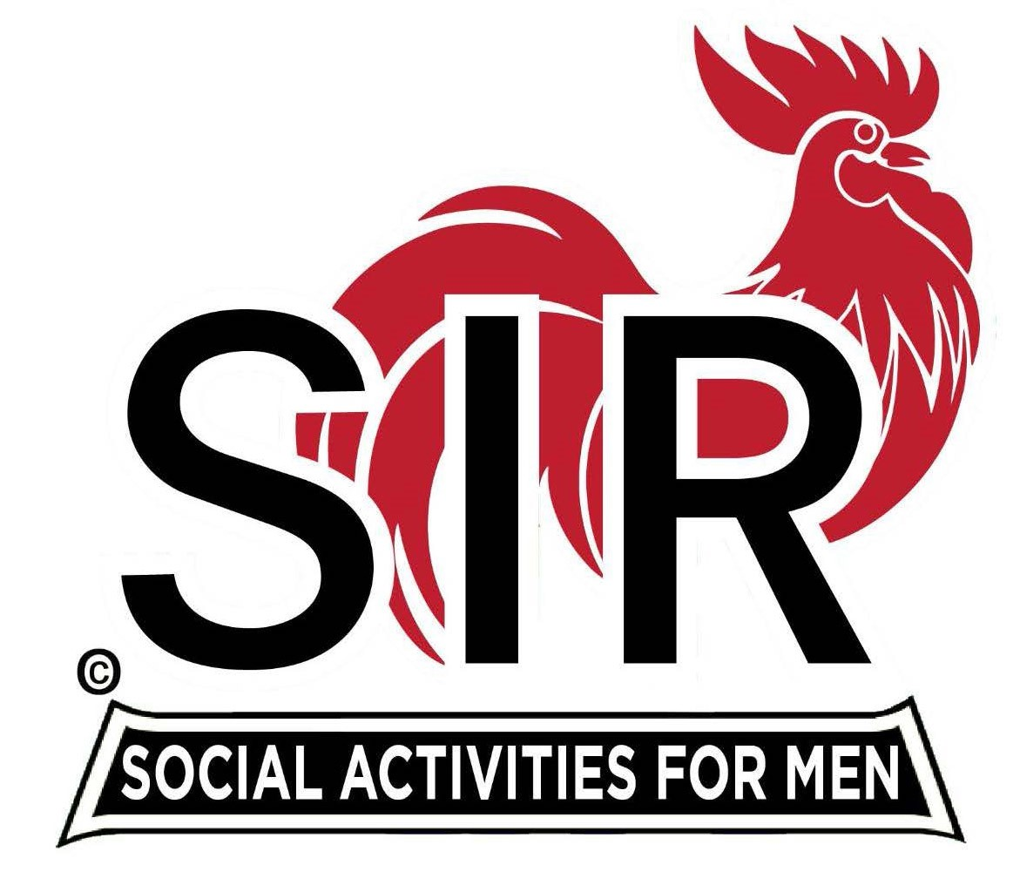
Las Trampas Branch 116
BEC Meeting Agenda
January 16, 2023, 9:15 AM at Boundary Oak

The Mission of SIR is to enhance the lives of our members through fun activities, events and luncheons while making friends for life.

9:15 am Call to order; Secretary, Paul Ramacciotti, confirm quorum and Approval of
Nov 21, 2022 BEC meeting minutes

9:20 am Standing Reports

- Treasurer – Jeff Johnson – Financial Update
- Luncheon Report – Phil Goff

- January Boundary Estimated Count

3. Membership – Phil Goff

4. RAMP Department Head Reports:

- Recruitment – Don Schroeder
- Activity Coordinator – Mike Ward
- Membership Relations - Michael Barrington
- Publicity – Paul Russell

5. Covid Compliance – Kevin Donahue

9:40 am Little SIR Updates – Alan Pope

- Speaker Update – Jimmy Friedman (6th degree Black Belt)
- Birthday Boys – December and January
- Holiday Party Wrap Up

9:50 am Misc. Updates & New Business

- 2023 Roster Book
- Volunteers Needed: Recruiting Assistants, Speaker Team Members, Member Relations Assistants, Activity Leader Assistants

10:15 am Adjourn: Lunch Preparations

